# **Fungicides can be beneficial, especially when disease is present.**



DOI: doi.org/10.31274/cpn-20210318

# 

# **When disease is not present or is not a threat/identified then:**

* Not at tassel, it is possible to wait for a fungicide application.
* At tassel, silking, or pollination; can wait until disease is threat/identified.
* Sprays before threat/found; can spray but reduces probability estimated savings.
  + Single mode of action can protect for about 2 weeks.
  + Mixed mode of action can protect for about 3 weeks.
  + Think about expense, mixed mode tends to be more expensive.

When disease is present use a high rated fungicide for the disease identified (VG to E); See corn fungicide efficacy guide (Crop Protection Network)

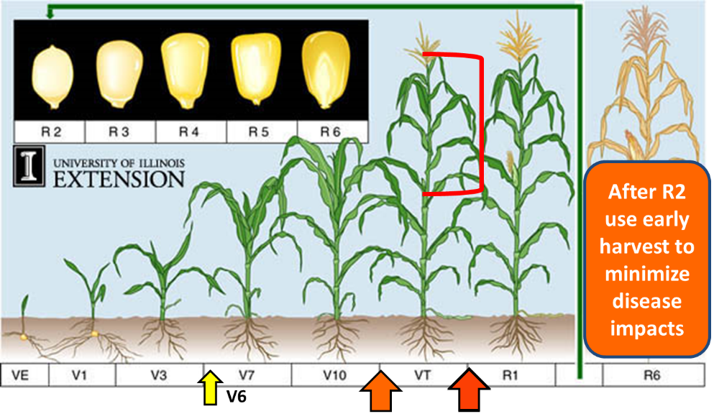

Sprays to save most grain yield should protect the ear leaf and above (red bracket). Orange to read consider optimal spray window. The yellow arrow shows roughly V6 growth stage.

|  |  |
| --- | --- |
|  | The lower canopy can have some disease. |

# **What does 5% look like?**

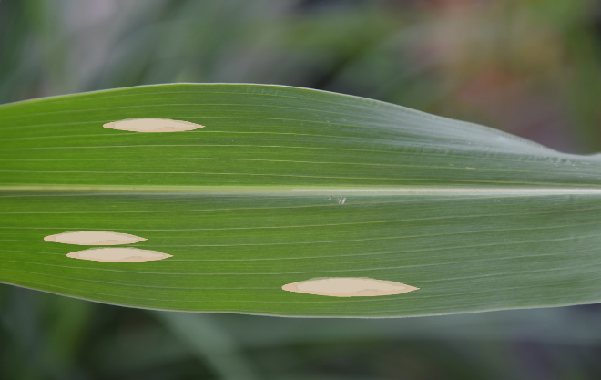 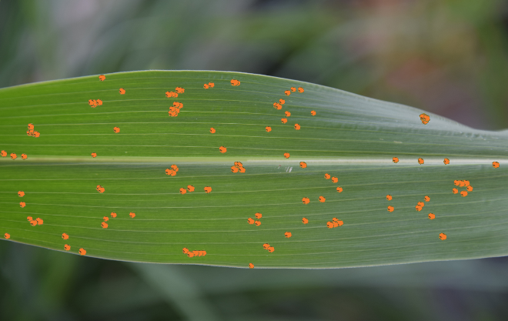

<https://severity.cropprotectionnetwork.org/crop/corn/southern-rust-0>

# **Disease to be on the lookout for:**

**Tar Spot**

DOI: doi.org/10.31274/cpn-20210820-1

Likes cooler weather, but scouting is important.